- Create a ClusterIP service for an Apache web server pod.

Step 1: Create the YAML file

vi apache-pod-service.yaml

Paste the below YAML and save.

apiVersion: v1
kind: Pod
metadata:
name: apache-pod
labels:
app: apache
spec:
containers:
- name: apache-container
image: httpd:2.4
ports:
- containerPort: 80

---
apiVersion: v1
kind: Service
metadata:
name: apache-service
spec:
type: ClusterIP
selector:
app: apache
ports:
- protocol: TCP
port: 80
targetPort: 80

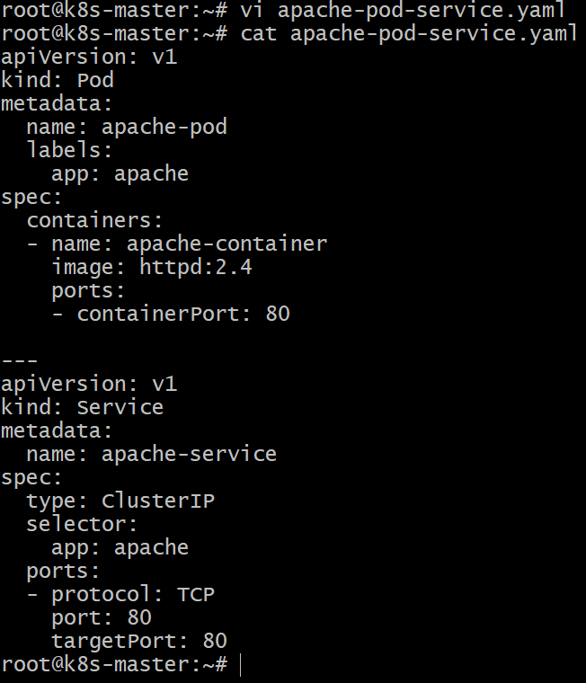

Step 2: Apply the YAML file

kubectl apply -f apache-pod-service.yaml

Output should be similar to:

pod/apache-pod created
service/apache-service created

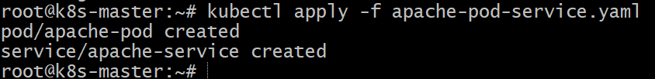

Step 3: Verify Pod

kubectl get pods

Example output:

```
NAME READY STATUS RESTARTS AGE
apache-pod 1/1 Running 0 15s
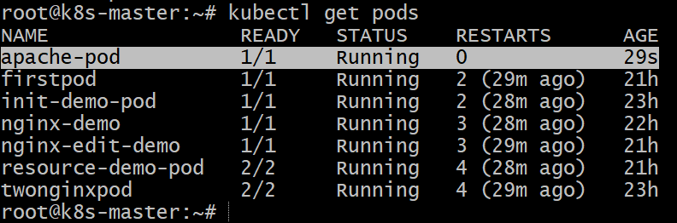

Step 4: Verify Service

kubectl get svc

Example output:

NAME TYPE CLUSTER-IP PORT(S) AGE
apache-service ClusterIP 10.96.152.120 80/TCP 10s

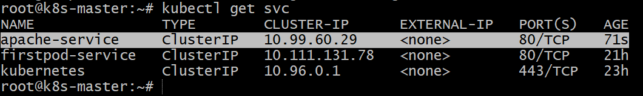

Step 5: Test the Service

kubectl get endpoints apache-service
curl 10.244.1.13:80

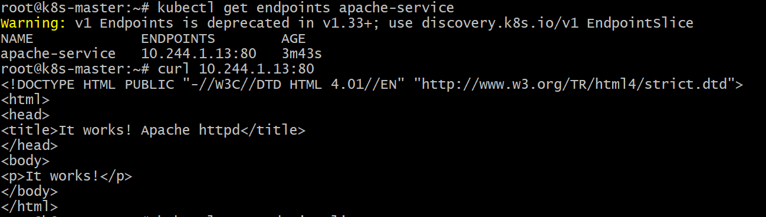

✅ **Key point:**
The separator `---` allows multiple Kubernetes resources in **one YAML file**.

- Expose an Nginx pod externally using a NodePort service.

Step 1: Create the Nginx Pod

Create a YAML file called nginx-pod-nodeport.yaml

vi nginx-pod-nodeport.yaml

Paste the below yaml content :

apiVersion: v1
kind: Pod
metadata:
name: nginx-pod
labels:
app: nginx
spec:
containers:
- name: nginx-container
image: nginx:latest
ports:
- containerPort: 80
---
apiVersion: v1
kind: Service
metadata:
name: nginx-nodeport-service
spec:
type: NodePort
selector:
app: nginx
ports:
- protocol: TCP
port: 80
targetPort: 80
nodePort: 30007

Explanation:

* type: NodePort → exposes the service outside the cluster
* port → service port inside cluster
* targetPort → container port
* nodePort: 30007 → external port accessible from outside

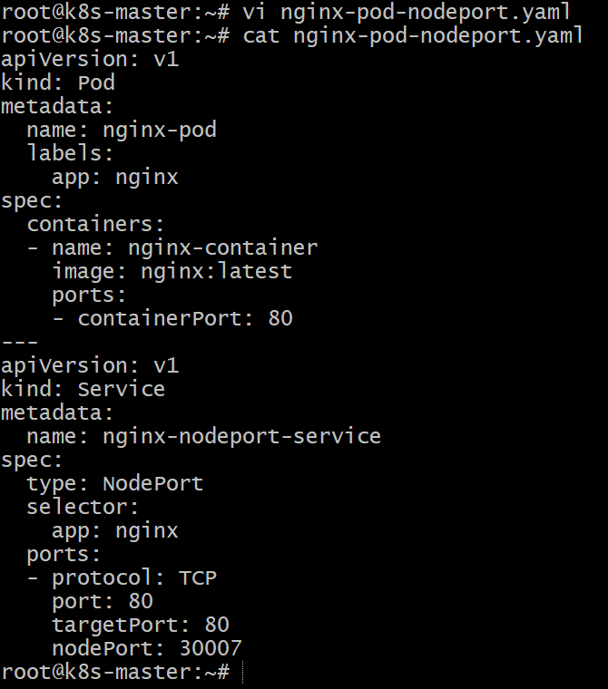

Step 2: Apply the Configuration

kubectl apply -f nginx-pod-nodeport.yaml

Expected output:

pod/nginx-pod created
service/nginx-nodeport-service created

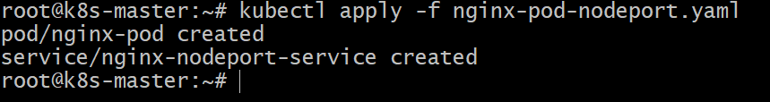

Step 3: Verify Pod

kubectl get pods

Example output:

NAME READY STATUS RESTARTS AGE
nginx-pod 1/1 Running 0 20s

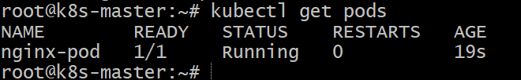

Step4: Verify Service

kubectl get svc

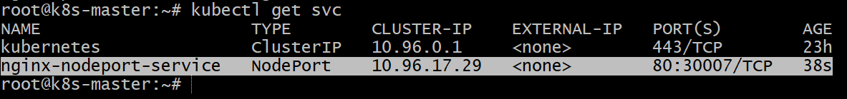

Here 30007 is the external port.

Step 5: Access the Nginx Web Page

Access in browser:

http://MASTER-PUBLIC-IP:30007
http://WORKER1-PUBLIC-IP:30007
http://WORKER2-PUBLIC-IP:30007

You should see the Nginx welcome page.



Conclusion

In this task, we created an Nginx Pod and exposed it externally using a NodePort Service. The Pod was configured with the label `app: nginx`, and the NodePort Service used this label as a selector to route traffic to the Pod. By specifying `type: NodePort`, Kubernetes opened a port (`30007`) on each node, allowing external users to access the Nginx web server using the Node IP and NodePort. This demonstrates how Kubernetes enables external access to applications running inside the cluster.

- Deploy a ReplicationController to maintain 3 replicas of an Nginx pod.

Step 1: Create the YAML File

vi nginx-rc.yaml

Paste the YAML configuration and save the file.

apiVersion: v1
kind: ReplicationController
metadata:
name: nginx-rc
spec:
replicas: 3
selector:
app: nginx
template:
metadata:
labels:
app: nginx
spec:
containers:
- name: nginx-container
image: nginx:latest
ports:
- containerPort: 80

Explanation:

* replicas: 3 → ensures that 3 Nginx pods are always running
* selector → identifies pods managed by the ReplicationController
* template → defines the pod configuration used to create replicas

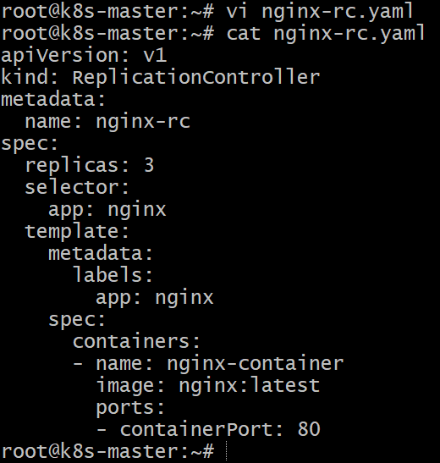

Step 2: Apply the YAML File

kubectl apply -f nginx-rc.yaml

Expected output:
replicationcontroller/nginx-rc created

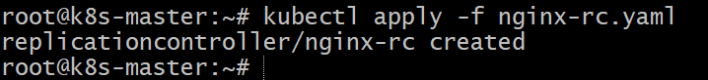

Step 3: Verify the ReplicationController

kubectl get rc

Example output:

NAME DESIRED CURRENT READY AGE
nginx-rc 3 3 3 20s

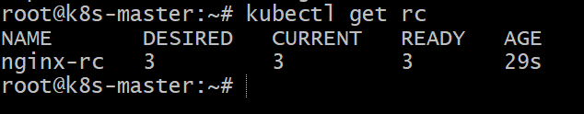

Step 4: Verify the Pods

kubectl get pods

You should see 3 running pods.

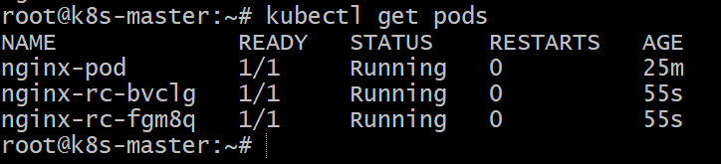

Step 5: Test Replica Self-Healing

Delete one pod:

kubectl delete pod <pod-name>

Check again:

kubectl get pods

The ReplicationController will automatically create a new pod to maintain 3 replicas.

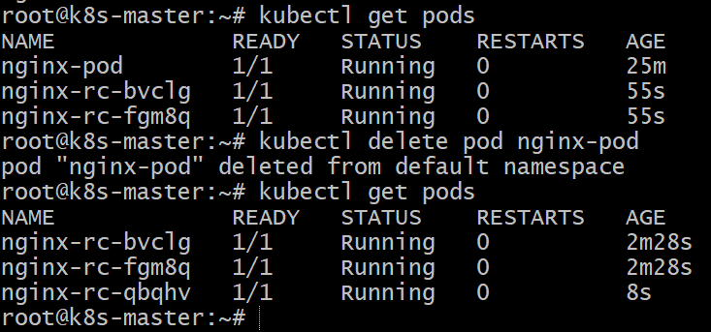

Conclusion

In this task, we deployed a ReplicationController to manage and maintain three replicas of an Nginx pod. The ReplicationController ensures high availability by continuously monitoring the number of running pods and automatically creating new ones if any pod fails or is deleted. Using the pod template and selector, Kubernetes manages the lifecycle of the pods and guarantees that the desired state of three active Nginx pods is always maintained in the cluster.

- Scale the ReplicationController from 3 replicas to 5 replicas.

Step 1: Check Current Replicas

kubectl get rc

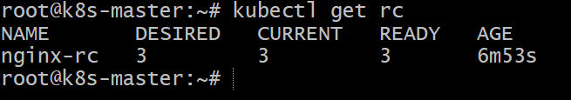

Step 2: Scale the ReplicationController

Run the following command:

kubectl scale rc nginx-rc --replicas=5

Output:
replicationcontroller/nginx-rc scaled

Step 3: Verify the Scaling

kubectl get rc

Example output:

NAME DESIRED CURRENT READY
nginx-rc 5 5 5

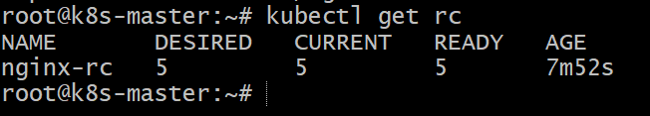

Check pods:

kubectl get pods

You should now see **5 running Nginx pods**.

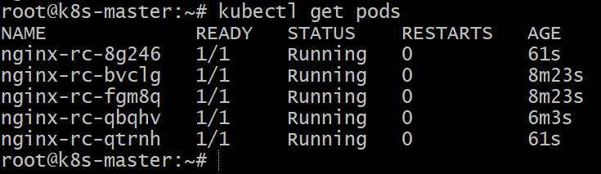

Conclusion

In this task, we scaled the ReplicationController from 3 replicas to 5 replicas using the `kubectl scale` command. Kubernetes automatically created two additional Nginx pods to meet the desired state. This demonstrates Kubernetes' ability to dynamically scale applications to handle increased workload and maintain availability.

- Create a ReplicaSet to manage pods based on multiple labels (prod and test).

Step 1: Create the YAML File

vi nginx-replicaset.yaml

Paste the YAML configuration and save.

apiVersion: apps/v1
kind: ReplicaSet
metadata:
name: nginx-rs
spec:
replicas: 3
selector:
matchExpressions:
- key: env
operator: In
values:
- prod
- test
template:
metadata:
labels:
app: nginx
env: prod
spec:
containers:
- name: nginx-container
image: nginx:latest
ports:
- containerPort: 80

Explanation:

* replicas: 3 → maintains 3 pods
* matchExpressions → selects pods with labels `env=prod` or `env=test`
* template labels → labels applied to pods created by ReplicaSet

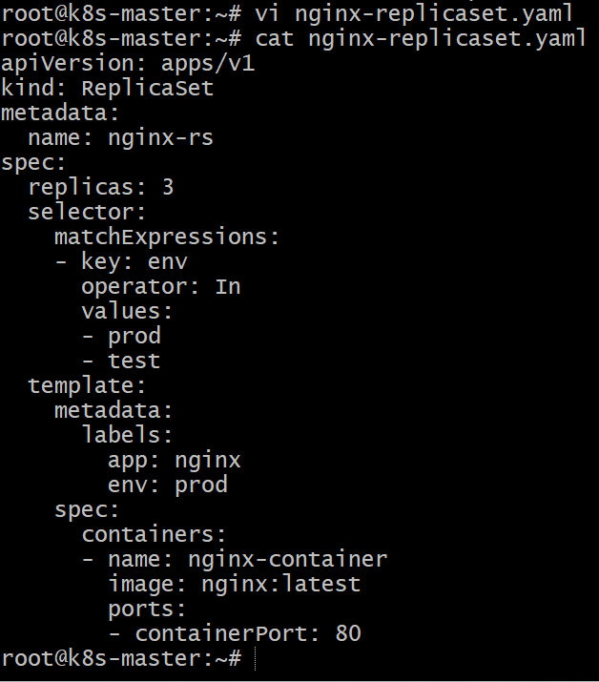

Step 2: Apply the ReplicaSet

kubectl apply -f nginx-replicaset.yaml

Expected output:
replicaset.apps/nginx-rs created

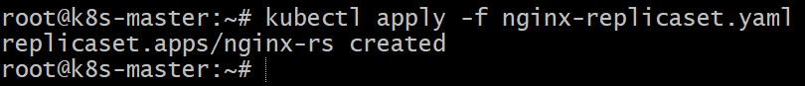

Step 3: Verify the ReplicaSet

kubectl get rs

Example output:

NAME DESIRED CURRENT READY
nginx-rs 3 3 3

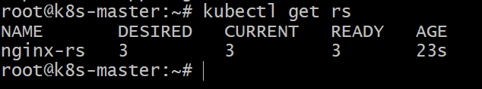

Step 4: Verify Pods

kubectl get pods --show-labels

Example output:

NAME READY STATUS LABELS
nginx-rs-abc1 1/1 Running app=nginx,env=prod
nginx-rs-def2 1/1 Running app=nginx,env=prod
nginx-rs-ghi3 1/1 Running app=nginx,env=prod

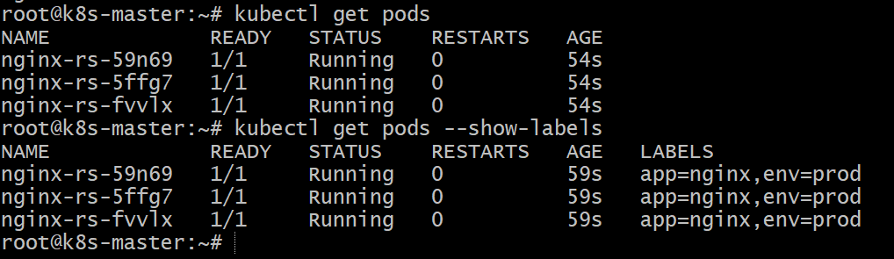

Conclusion

In this task, we created a ReplicaSet to manage Nginx pods using multiple labels (`prod` and `test`) with the help of `matchExpressions`. The ReplicaSet ensures that the desired number of pods is always running and selects pods based on specified label conditions. This demonstrates how Kubernetes uses label selectors to manage groups of pods efficiently.

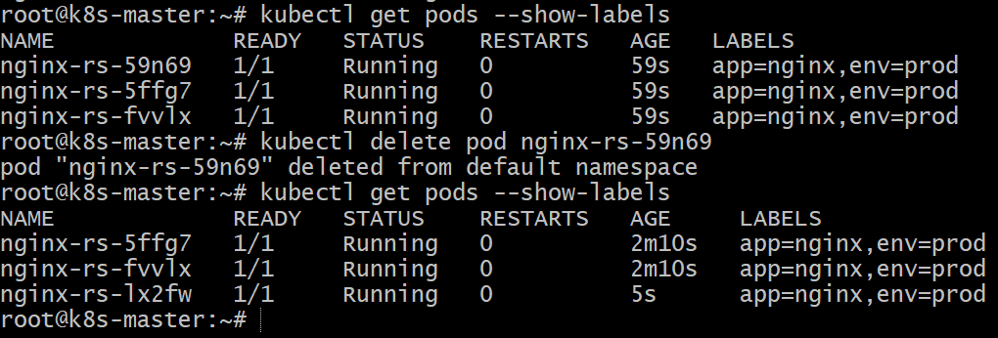

- Deploy a ReplicaSet that excludes pods with the label backend.

Step 1: Create the YAML File

vi nginx-rs-exclude-backend.yaml

Paste the YAML and save.

apiVersion: apps/v1
kind: ReplicaSet
metadata:
name: nginx-rs
spec:
replicas: 3
selector:
matchExpressions:
- key: tier
operator: NotIn
values:
- backend
template:
metadata:
labels:
app: nginx
tier: frontend
spec:
containers:
- name: nginx-container
image: nginx:latest
ports:
- containerPort: 80

Explanation:

* replicas: 3 → maintains 3 pods
* operator: NotIn → excludes pods with label `tier=backend`
* Pods created will have label ‘tier: frontend’

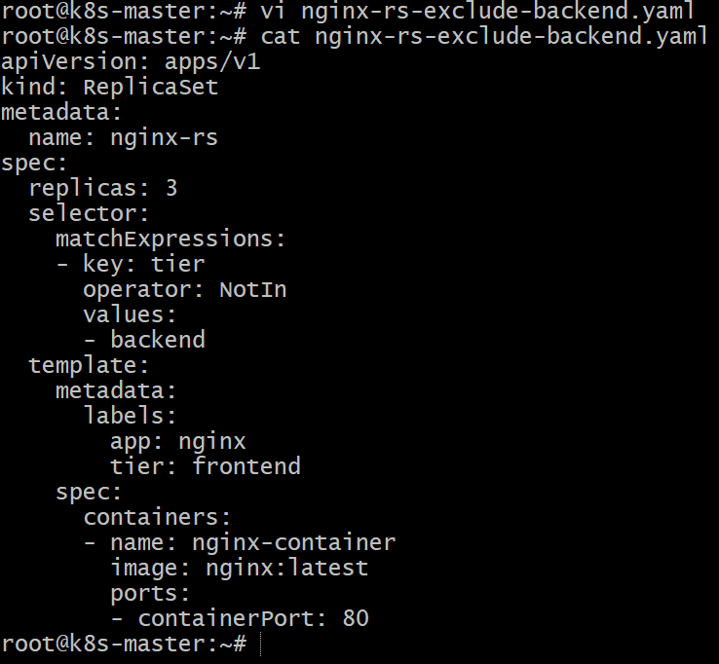

Step 2: Apply the ReplicaSet

kubectl apply -f nginx-rs-exclude-backend.yaml

Expected output:

replicaset.apps/nginx-rs created

Step 3: Verify the ReplicaSet

kubectl get rs

Example output:

NAME DESIRED CURRENT READY
nginx-rs 3 3 3

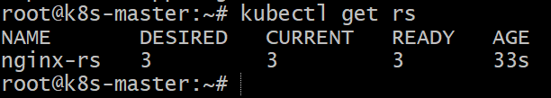

Step 4: Verify Pods and Labels

kubectl get pods --show-labels

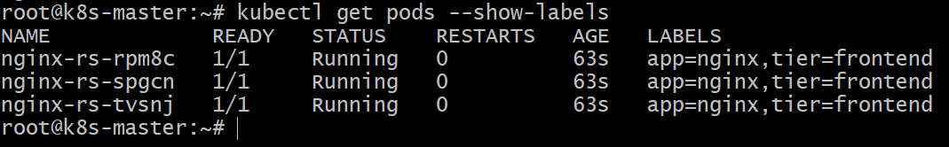

Pods with label backend will not be selected by this ReplicaSet.

Conclusion

In this task, we deployed a ReplicaSet that excludes pods with the label backend using the `matchExpressions` selector with the `NotIn` operator. The ReplicaSet ensures that only pods without the `backend` label are managed and maintains the desired number of replicas. This demonstrates how Kubernetes label selectors can control which pods are included or excluded from management.

- Test load balancing across multiple pods using a NodePort service.

Step 1: Create the YAML File

vi nginx-deployment.yaml

Paste the YAML and save.

apiVersion: apps/v1
kind: Deployment
metadata:
name: nginx-lb
spec:
replicas: 3
selector:
matchLabels:
app: lb-nginx
template:
metadata:
labels:
app: lb-nginx
spec:
containers:
- name: nginx-container
image: nginx:latest
ports:
- containerPort: 80

---
apiVersion: v1
kind: Service
metadata:
name: nginx-lb-service
spec:
type: NodePort
selector:
app: lb-nginx
ports:
- port: 80
targetPort: 80
nodePort: 30008

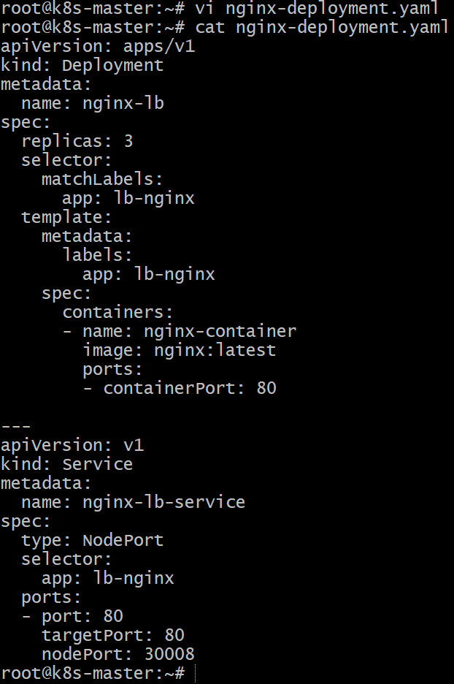

Step 2: Apply the Configuration

kubectl apply -f nginx-deployment.yaml

Expected output:

deployment.apps/nginx-lb created
service/nginx-lb-service created

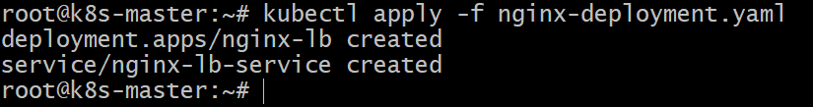

Step 3: Verify Pods

kubectl get pods

Example output:

NAME READY STATUS
nginx-lb-6f7c9d8c7f-abc12 1/1 Running
nginx-lb-6f7c9d8c7f-def34 1/1 Running
nginx-lb-6f7c9d8c7f-ghi56 1/1 Running

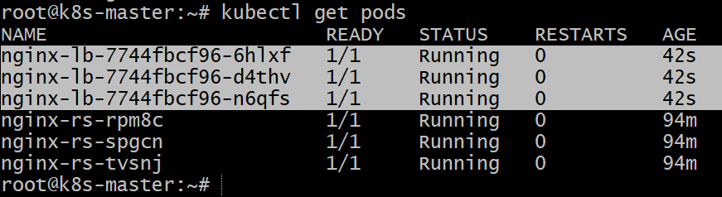

Step 4: Verify Service

kubectl get svc

Example output:

NAME TYPE CLUSTER-IP PORT(S)
nginx-lb-service NodePort 10.96.22.50 80:30008/TCP

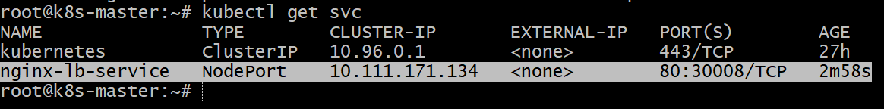

Step 5: Test Load Balancing

Access in browser or curl:

http://<Node-public-IP>:30008

Refresh multiple times to test load balancing across pods.



Step 6 : how to delete the service created above (optional)

The ReplicaSet was automatically recreated because it was managed by a Deployment. In Kubernetes, the Deployment controller maintains the desired state of the application. When the ReplicaSet was deleted manually, the Deployment immediately created a new ReplicaSet to maintain the required number of replicas. To permanently remove the ReplicaSet, the Deployment managing it must be deleted.

You must delete the Deployment, not the ReplicaSet , and service

Check the Deployment :

kubectl get deployments
Kubectl get svc

You will likely see:

NAME READY UP-TO-DATE AVAILABLE
nginx-lb 3/3 3 3

Delete the Deployment :

kubectl delete deployment nginx-lb
Kubectl delete svc nginx-lb-service

Verify everything is deleted :

kubectl get deployments
kubectl get svc
Kubectl get rs

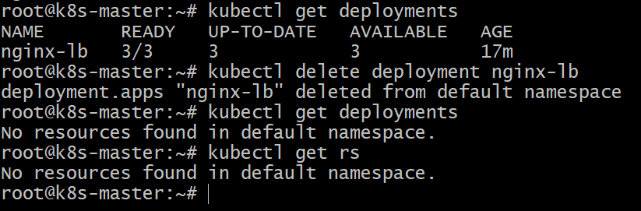

Conclusion
In this task, we deployed multiple Nginx pods using a Deployment and exposed them externally using a NodePort Service. The service distributes incoming requests across all available pods automatically. By accessing the application through the Node IP and NodePort, Kubernetes performs built-in load balancing, ensuring traffic is shared among the running pods and improving application availability and scalability.

- Delete a ReplicationController without affecting the running pods.

Step 1: Check the Existing ReplicationController

kubectl get rc

Example output:

NAME DESIRED CURRENT READY
nginx-rc 3 3 3
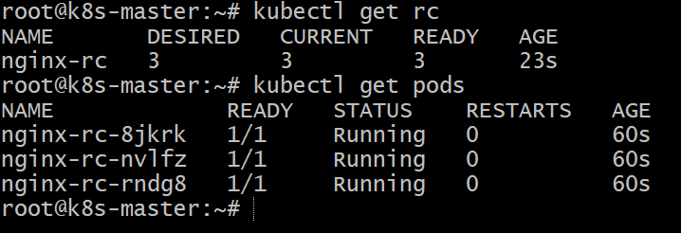

Step 2: Delete the ReplicationController but Keep Pods

Use the **--cascade=orphan** option.

kubectl delete rc nginx-rc --cascade=orphan

Expected output:

replicationcontroller "nginx-rc" deleted

Explanation:

* --cascade=orphan → deletes only the ReplicationController
* The existing pods will continue running.

Step 3: Verify the ReplicationController is Deleted

kubectl get rc

You should see:

No resources found

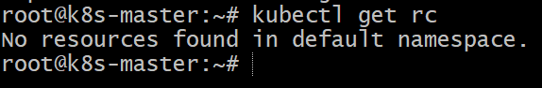

Step 4: Verify the Pods are Still Running

kubectl get pods

Example output:

NAME READY STATUS RESTARTS AGE
nginx-rc-abc12 1/1 Running 0 5m
nginx-rc-def34 1/1 Running 0 5m
nginx-rc-ghi56 1/1 Running 0 5m

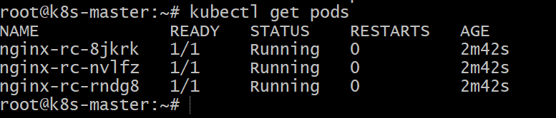

Conclusion

In this task, we deleted the ReplicationController while keeping the running pods intact by using the `--cascade=orphan` option. This removed the controller that manages the pods but did not terminate the pods themselves. As a result, the pods continue running independently, although they are no longer managed by the ReplicationController.

